**User Defined Route table**

When we add virtual machine to virtual network we will notice that we are able to communicate with each other over the network automatically. you do not need to specify gateway, even though vm are in different subnet

The flow of communication is possible because azure use series of system route how ip traffic flow.

**Default Route:**

* From within same subnet
* From subnet to another within VNet (different subnet)
* VM to internet
* From Vnet to another VNet through VPN gateway or VNET Peering
* From VNet to on premises network (site to site) through VPN Gateway

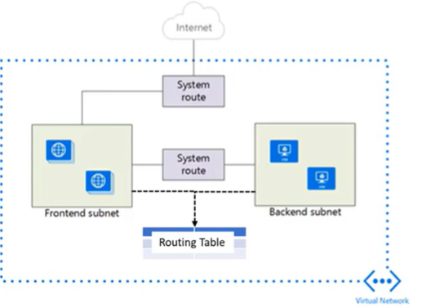

In some cases we want to override system route rules than we use user defined rule

EX.

Company have policy that we have not sent company information to another part via mail or something so how can it monitor for that we have software for that then we use custom route policy

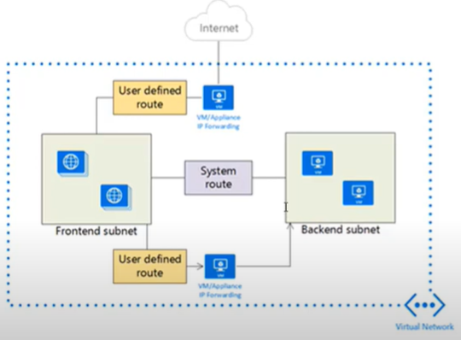

Here in this figure, we see that we tell user define route that any traffic originated from frontend subnet it will go from vm application/firewall to backend subnet

* User define traffic is only for traffic leaving subnet (outgoing). we can not create route to specify traffic come to subnet from internet
* Appliance we are forwarding traffic we can not make in same subnet
* VM appliance is like it will take traffic log it and then forward it. (It will not take it for itself)

**Configuration:**

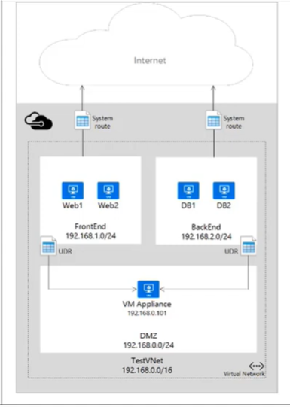

Create VNET and make 3 subnets in it

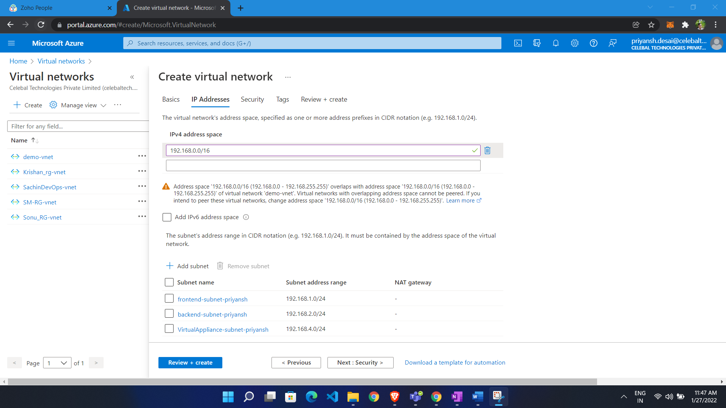

Now we are going to create route table:

* Search for route table
* Click create
* Choose RG
* Give name
* Propagate gateway route to yes (from virtual network we also browse internet)

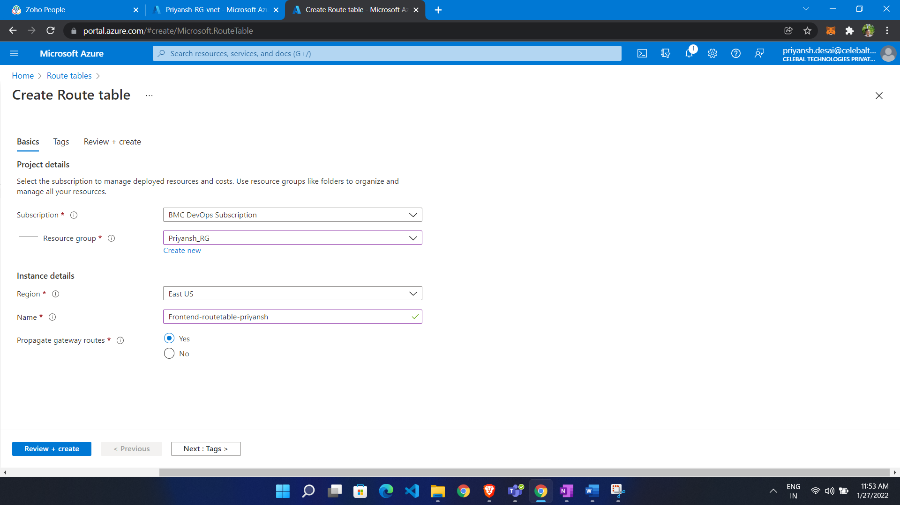

Now create VM in each subnet

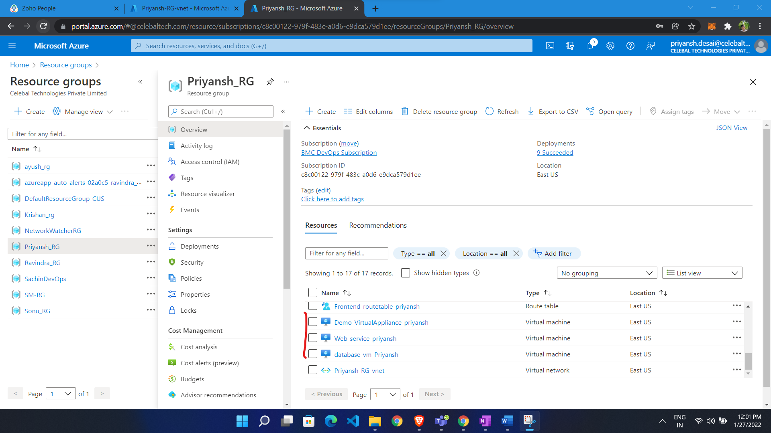

Now associate route table to subnet

* Go to route table
* Select subnet from left pan
* Click associate
* Select VNET and select subnet

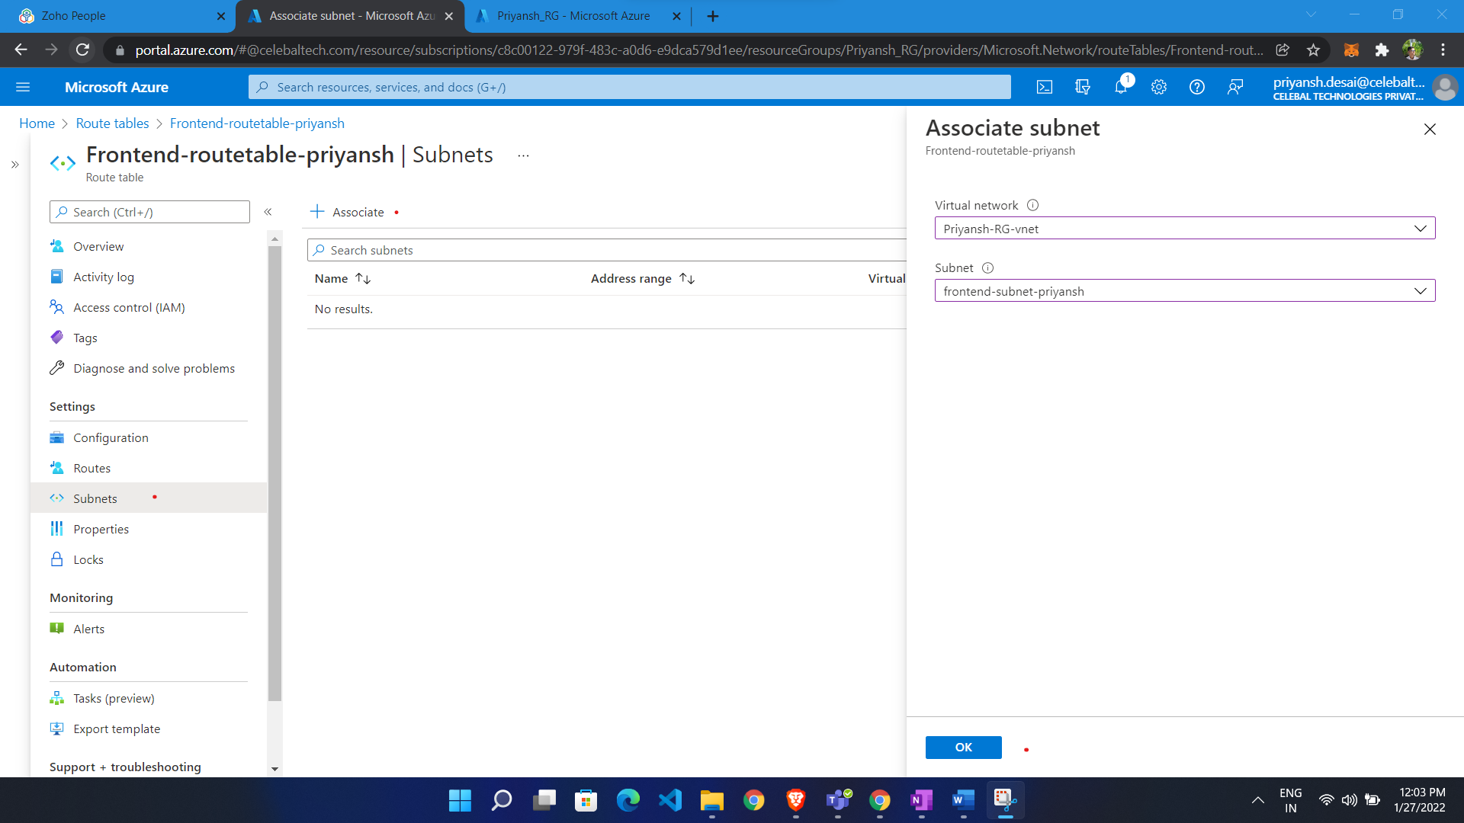

Now we are going to write routes

* Go to route table
* Select routes from left side menu
* Click ADD
* Give name
* Give address prefix (destination address prefix range)
* Select next hope (virtual Appliance)
* Add next hope address ( IP of virtual appliance vm)

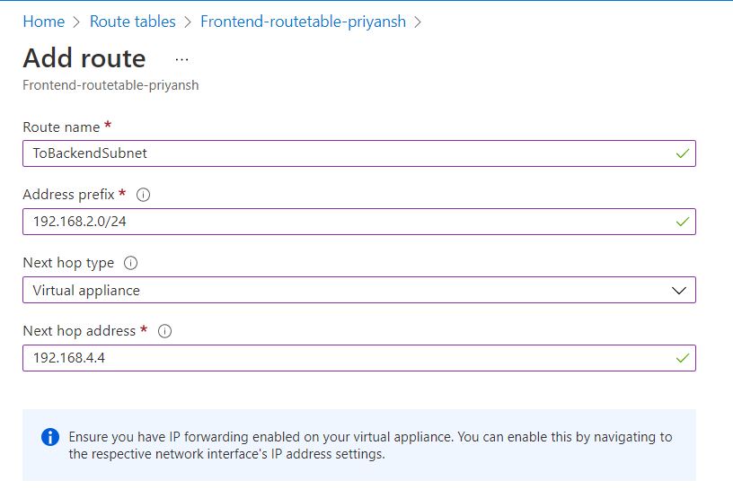

Virtual Appliance are responsible for ip forwarding so we have to do it

* Go to virtual appliance vm
* Go to networking
* Go to network interface card
* Go to ip configuration
* Enable ip forwarding

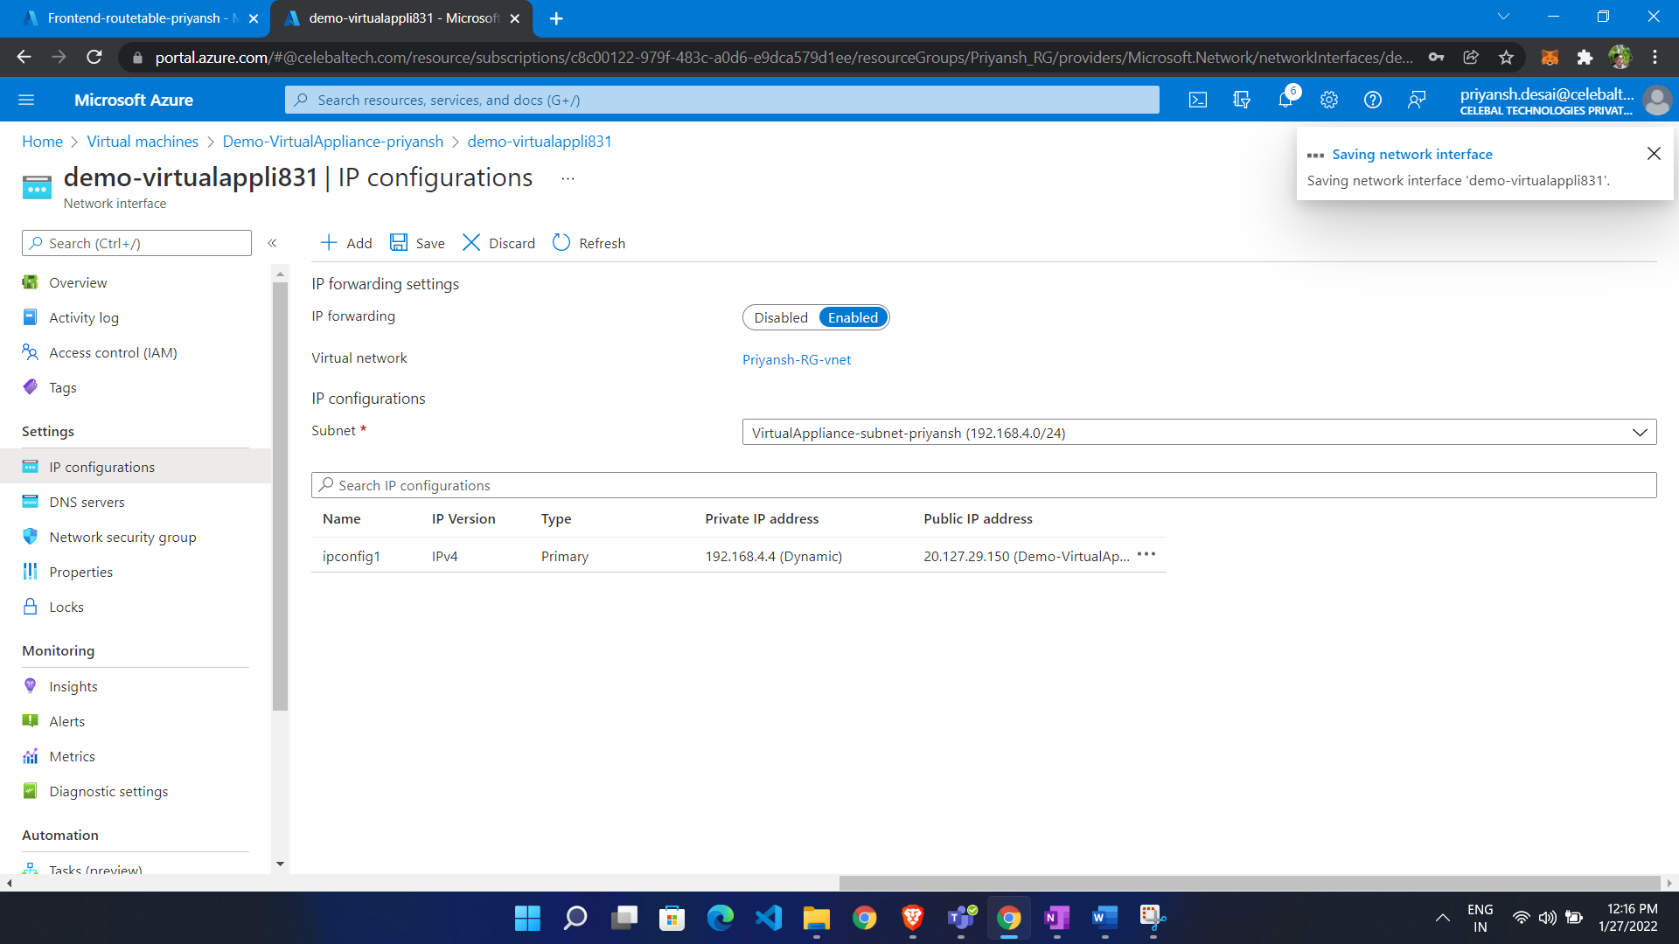

IP forwarding in VM also

**Set-itemProperty -Path HKLM:\SYSTEM\CurrentControlSet\Services\Tcpip\Parameters -Name IpEnavleRouter -Value 1**



Then restart VM

We see in network watcher:

* Select resource group
* Virtual machine
* Network interface
* Source ip
* Destination ip

